December 10, 2017

Second Sunday of Advent

“Show us Your steadfast love, O Lord, and grant us Your salvation.”

Monday 8:00 a.m. Special Intentions of a Parishioner

Special Intentions of a Parishioner

Helen Kelly – Tom & Family

In Thanksgiving to Our Lady – Ana Prior

Tuesday 8:00 a.m. Peter, Benedicto & Tadeo – Vinh Nguyen

Special Intentions of a Parishioner

Wednesday 8:00 a.m. Kurtis Pricop – Buddy Brennan

Thursday 8:00 a.m. Bob Cowan – The Wrafter Family

Ray Campbell – Charlotte & Family

Marge & Fred Isley – Family

Cathy Koehler – Larry & Family

Ron Gingrich – Betty & Family

Friday 8:00 a.m. Deceased Members of the Harshuk Family – Mary & Sylvia

Father Phil Sherlock – Sharma Family

Mick D’Mello – D’Souza Family

Eleanor Tobolski – Nancy Hupf

Friday 10:30 a.m. Mass at Golden Years Nursing Home

Friday 10:45 a.m. Mass at Cambridge Country Manor

Saturday 5:00 p.m. Joan de Battista – Daughter Sonia & Family

Clarence & Cody Smith & Family – Gerard Schmidt

Nancy & Charlie Ratford – Fred & Kathy Ratford & Family

Hugh & Dollie Higgins – Family

Jennie Crystal O’Geil – Nick & Jennie Kuchma & Family

Deceased Members of the Kuchma & Worobec Families – Family

Chrissy Pink – Jack, Stella & Family

Angelo Gaetan – Benedetti Family

PRAYERS for the SICK – As a faith community, we pray for all who struggle with illness and for their families. At this time we especially remember Blaine Galway, Kevin Young and Anton Gale.

PRAYER NETWORK – Are you in need of prayerful support? Or would you like to help us pray for those who have requested prayers? We have a parish Prayer Network: People who pray for those in need of prayers. Please contact Reggie Weidinger at 519-653-0625 or edwardweidinger@rogers.com

MANY THANKS! The Catholic Women’s League would like to thank everyone who came out to their Christmas Pot Luck Supper. This year’s quilt draw winner was Brad Kinzie. Congratulations Brad!

KEEP CHRIST in CHRISTMAS – This weekend, we welcome Knights of Columbus Council #4916, whose members are here with “Keep Christ in Christmas” pins. All proceeds will go to support the Knights of Columbus charities. Your support is greatly appreciated.

LOOKING for “THAT SPECIAL GIFT”? The 10:30 Adult Choir will have CD’s available of their 100th Anniversary recording after the 8:30 a.m. and 10:30 a.m. Masses today – Sunday, December 10th – and on Sunday, December 17th. (If neither date works for you, please call Marilynn (519-653-3383) and a CD will be made available.) The cost is $10 each – A real steal, with all proceeds going to our “up and coming” Organ Renovation Fund.

CHILDREN from KINDERGARTEN to GRADE 6

are invited to help us celebrate the Birth of Jesus


by playing a role in our annual Christmas Pageant.

Anyone who is interested in participating or helping is asked to meet Jennifer

at the front of the Church near the baptismal font

today – Sunday, December 10th – at 11:30 a.m.

We will meet again on Sunday, December 17th, from 11:30 a.m. to 12:00 noon

downstairs in the Parish Hall to practise and try on costumes.

Then on Christmas Eve, we will meet downstairs at 4:00 p.m.

If you have any questions, please contact Jennifer by text at 519-504-6148 or by email at Jennifer.Kruithof@wcdsb.ca

CAMBRIDGE KIWANIS BOYS CHOIR ANNUAL CHRISTMAS CONCERT – Here at St. Clement’s on Sunday, December 10th, at 3:00 p.m.! The Fairview Bell Ringers will be joining the boys for this concert. Tickets may be purchased at the door. $30 for families of 6; $10 ea. for adults/seniors/students; $7 ea. for children.

ADVENT HYMN FESTIVAL – “O Holy Mary” featuring the Diocesan Choir and the Spanish Choir of St. Michael’s Parish, Oakville – Sunday, December 10th, at 7:00 p.m. at the Cathedral Basilica of Christ the King, 714 King St. West, Hamilton. Everyone is welcome.

COPING with the HOLIDAYS WHEN YOU HAVE LOST A LOVED ONE –

An evening of reflection and strategies for coping at Christmas, facilitated by Dr. Wendy Hofman.

Date: Monday, December 11th.

Place: St. Mary of the Visitation Parish, 16 Cooper St., Cambridge. Time: 7:00 to 8:30 p.m.

This event is free of charge. Please call 519-653-4443 to reserve a seat.

(Those who do not register are still free to attend.)


2017 ST. VINCENT de PAUL GIVING TREE CAMPAIGN

Once again this year, the Giving Tree is up with tags on it for you to take.

More tags have been added to the Giving Tree as more calls for assistance have been received.

In past years, your generous response to our plea for help has been heart-warming

and sincerely appreciated by the families who turn to us for assistance at Christmas.

If you have chosen to assist the St. Vincent de Paul Society by taking a tag, please RETURN the gift UNWRAPPED (with the tag attached) to the Church or to the Rectory by Sunday, December 17th. After that weekend, all the gifts are sorted and delivered. Gifts returned after the cut-off date (December 17th) may not get to a needy child.

This year, the St. Vincent de Paul Society will again be distributing food vouchers instead of groceries and so cash donations would be appreciated. Special Christmas donation envelopes are available for your convenience. If you would like a tax receipt, please include your full name and address. Thank you!

2017 KNIGHTS of COLUMBUS COUNCIL #4916 CHRISTMAS POT LUCK SUPPER –

Date Sunday, December 17th.

Place St. Gregory’s Parish, 10 St. Gregory Drive, Cambridge.

Time Social at 4:00 p.m., dinner at 5:00 p.m.

Please RSVP to Brian Whitfield, 519-622-5059 or Whitfield@sentex.ca

Paul O’Neill, 519-658-4079 or pauloneill@gmail.com


CHRISTMAS DECORATING

of our beautiful Church will take place on Monday, December 18th, at 8:30 a.m.

We invite you to join us if you are able.

Some climbing and heavy lifting may be required.

Thank you!

LONGEST NIGHT PRAYER SERVICE –

If you are grieving, lonely or sad for any reason as the Christmas season approaches,

you are invited to attend this ecumenical evening of Scripture, music and prayer;

fellowship will follow.

Date Thursday, December 21st.

Place St. Francis of Assisi Parish, 49 Blueridge Ave., Kitchener.

Time 7:00 p.m.

MARIAN RESIDENCE CATHOLIC RETIREMENT HOME is looking for a Personal Support Worker for the night shift and another for the day shift starting immediately. The home is owned and operated by the Sisters of Our Lady Immaculate. Please send your resumé to marianresidence@bellnet.ca

+ + + + +

ADVENT PRAYER

God of love, You were so generous,

sending the presence of Your Beloved to dwell among us

and tell us who You are.

Encourage me during this Advent season

to continue in the sharing of this loving presence

through my attentiveness, given in prayer and in deeds.

You who dwell within me,

remind me often to let go of my busyness and my hurriedness

so that I can be with others in a loving way.

Convince me that “being” is as important as “doing.”

Thank you for Your strengthening presence.

Thank you for being with me.

Amen.

+ + + + +

He will tend his flock like a shepherd; he will gather the lambs in his arms; he will carry them in his bosom, and gently lead those that are with young – Isaiah 40:11

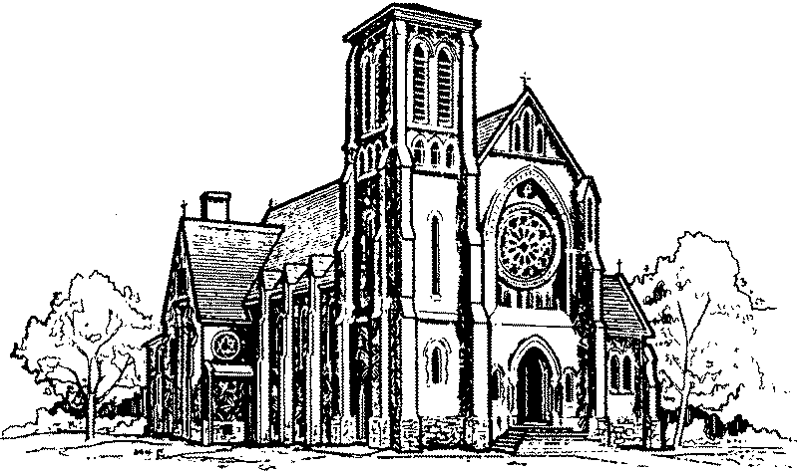
ST. CLEMENT PARISH
PASTORAL TEAM
Rev. Peter Tuyen Nguyen – Pastor
Rev. Ed Hinsperger – In Residence
Sr. Elaine Weinstein, S.S.N.D. – Pastoral Assistant
Mrs. Franki Baumtrog  Mr. Dan Schmalz  Mrs. Dee Donahue
LORD’S DAY MASSES

SEPTEMBER TO JUNE
Saturday – 5:00 p.m.
Sunday – 8:30 a.m., 10:30 a.m., 12 noon
JULY & AUGUST
Saturday – 5:00 p.m.
Sunday – 7:30 a.m., 9:00 a.m., 11:00 a.m.

WEDDINGS
Wedding dates are booked with the Pastor.
Give us at least 6 months’ advance notice.
WEEKDAY MASSES
Monday to Friday – 8:00 a.m.

RECONCILIATION
After the Wednesday 8:00 a.m. Mass
(until finished).
Saturday – 4:00 p.m. to 4:45 p.m.
Also by appointment.

BAPTISMS
On the first Sunday of each month,
following the last Lord’s Day Mass.
Parental preparation is required.
SCHOOLS
St. Joseph School: 519-653-4482  St. Michael School: 519-653-3351
St. Benedict School: 519-621-4050
NEW IN THE PARISH? We welcome you!
Please fill out a registration form (found in the vestibule).

745 DUKE ST.
CAMBRIDGE, ONTARIO
N3H 3T7
Telephone: 519-653-6123
Fax: 519-653-4393
E-mail: stclements@rogers.com

Website:

www.stclementsparish.ca

