June 24, 2018

Nativity of St. John the Baptist

“I praise You, for I am wonderfully made.”

Monday 8:00 a.m. Special Intentions of a Parishioner

Special Intentions of a Parishioner

Special Intentions of a Parishioner

Mary Szwajkowski – The Dobranski Family

Tuesday 8:00 a.m. Special Intentions of a Parishioner

Joseph Markow – Larry, Cheryl & Family

Velma MacDonald – Family

Barbara Sabila – Family

Wednesday 8:00 a.m. Special Intentions of a Parishioner

Frances Frank – Bernadette & John DeBoer

Harry Lemieux – Agnes Ford

Thursday 8:00 a.m. Judy Dalrymple – Kaaren Stuss

Friday 8:00 a.m. Special Intentions of a Parishioner

Deceased Members of the Maceachen & Gillis Families – Joe & Cecilia

Philip Johnson – Kathleen & Debbie

Frances Frank – Debbie Schmidt

Rescheduled from last week:

Friday 10:45 a.m. Mass at Cambridge Country Manor

Saturday 5:00 p.m. Special Intentions of the 2018 SSND Jubilarians – Sister Elaine

Leonard Joseph Arsenault – Wife Dawn & Family

Special Intentions of Dawn Montrait & Family

Frances Frank – Mary Jordan & Family

Margaret Mary O’Brien – Bernadine & Jerry Galway

Rita Costello – Anne Marie Ezekiel

Stefania Akudowicz – Joan Schefter

Jack Kreager – Maura Simpson

Anita Potts – Lori Proud

- Sunday, June 24th, is St. Vincent de Paul Sunday, and collection boxes have been placed at the Church doors. Your ongoing support is a tremendous help in our ministry to the needy. Please give as you are able. Thank you!
- Prayers for the Sick – As a faith community, we pray for all who struggle with illness and for their families. At this time, we especially remember Blaine Galway, Kevin Young and Anton Gale.
- Prayer Network – Are you in need of prayerful support? Or would you like to help us pray for those who have requested prayers? We have a parish Prayer Network: People who pray for those in need of prayers. Please contact Reggie Weidinger at 519-653-0625 or edwardweidinger@rogers.com
Thank you, Sister Elaine, and may God bless you!
This weekend, we are giving Sister Elaine a farewell celebration. A Mass of Thanksgiving will be offered on Sunday at 12:00 noon, followed by a luncheon reception in the Parish Hall. Everyone is welcome; please join us. It’s an opportunity to thank Sister Elaine for her ministry and to say our “good-byes.”
A Grateful Good-Bye to Sister Elaine
Dear Parishioners of St. Clement
and Friends of Sister Elaine,
I would also like to extend my gratitude to Sister Elaine, now retiring as our Pastoral Assistant. Sister has served St. Clement Parish since January 2014 and is returning to her Notre Dame community after 4-1/2 years of ministry with us. We will miss her warm greetings at Mass, her outreach to the sick and shut-in members of the parish, and her sympathetic support of the bereaved. Sister Elaine also facilitated the R.C.I.A. programme, sharing her love of God with those exploring the Catholic faith, and supported our catechists and children’s liturgists in their ministries. Let us pray to our Heavenly Father, who is never outdone in generosity, to bless Sister graciously for her many kindnesses. May her ministry at the Motherhouse be blessed with companionship and many joys!
On behalf of all the parishioners at St. Clement, we sincerely thank you, Sister Elaine! You will be greatly missed at St. Clement! – Father Peter
Father Peter visits
with Dad in Vietnam
Dear Parishioners and Friends,
Last weekend, we celebrated Father’s Day and this year I am blessed to have a Father’s Day visit with my own dad (86 years old) in Vietnam. I am looking forward to seeing him and my siblings. A family reunion has been planned and I will be away for several weeks, returning from summer vacation on July 23rd. During this time, the parish will be in the competent care of our parish staff, Father Ed, Father Tim and Deacon Michael. I am grateful for their ministerial assistance and I will remember you all in my prayers.
– Father Peter

Catholic Women’s League News – The C.W.L. would like to thank all the parishioners who joined the League for the monthly Coffee/Tea Socials. They are now taking a break for July and August but will start again on September 9th after the 8:30 a.m. and 10:30 a.m. Masses. They would also like to thank all the members who donated baking and served at the Socials.

EMPLOYMENT OPPORTUNITY: Caregiver/Housekeeper.
Family in this parish seeking a caregiver for elderly parents. Please call the parish office (519-653-6123).

Effective Next Weekend – Sunday, July 1st, 2018 –

the Weekend Summer Mass Schedule during the months of July & August will be:

Saturday at 5:00 p.m.;

Sunday at 9:00 a.m. and 11:00 a.m.

Please share this with your Catholic friends who visit St. Clement’s in the summertime.

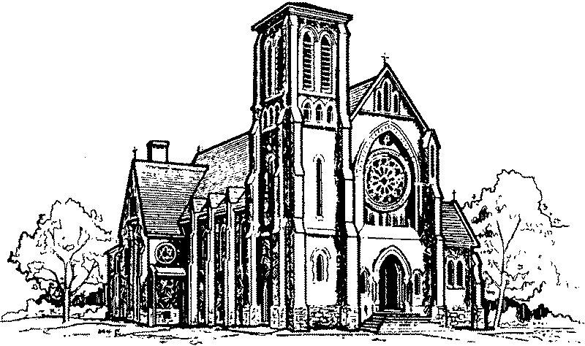
Are you troubled? Do you need spiritual support? The Sisters of the Carmel of St. Joseph will pray for you during the Novena to Our Lady of Mount Carmel, July 8th to 16th. Please send your name, address and prayer intention(s) to: Carmel of St. Joseph, 1127 Carmel-Koch Road, R.R. #1, St. Agatha, ON, N0B 2L0.

Catholic Meet-Up: Beach Day @ Turkey Point! Saturday, July 14th! A way for young adult Catholics (19 to 39) to meet and connect! Meet us at 10 a.m. in the parking lot at St. Thomas the Apostle Church (715 Centre Road, Waterdown) to carpool. Or meet us at 11:30 a.m. in front of the Turkey Point Hotel, 93 Cedar Drive, Turkey Point/Simcoe, ON. It’s right across from the beach. Come enjoy the sun, the water and great company. Check out the “Hamilton Catholic Young Adults” page on Facebook or e-mail steventebay22@hotmail.com

Annual Novena to St. Ann, at St. Ann’s Roman Catholic Church, 120 Sherman Ave. North, Hamilton – Wednesday, July 18th, to Thursday, July 26th. Each evening begins at 7:00 p.m. with Mass, followed by a blessing with the relic of St. Ann, novena prayers and confessions. On Friday, July 20th, Anointing of the Sick will take place. On the Feast of St. Ann – Thursday, July 26th – Bishop Crosby will celebrate the Mass and a reception will follow in St. Ann’s School gymnasium. All are welcome. Wheelchair/walker accessible.

WALKING PILGRIMAGE for ALL AGES – AUGUST 4th to 11th, 2018.
Participate for a day, a weekend or the full eight-day trip.
Visit www.ignatiusguelph.ca (under Programs) for information and registration.
What the Walking Pilgrimage is about:
Nourishing your spirituality Enjoying the great outdoors
Exercising – 20 to 30 km per day! Having fun, great food, and making new friends
Those who walk the Guelph-to-Midland pilgrimage find it to be a unique, grace-filled experience. For eight days, 50 to 90 pilgrims pray and sing, laugh, share stories and eat amazing meals. The journey, though not always easy, is always rewarding. In 2017, the oldest participant was 82 and there was every age in between: a young mother brought her 2-year-old, and the youth helped push the stroller and cared for the child while Mom set up and took down camp each day. There are support vehicles to assist with a lift up a hill or a return to camp for a shorter day. Join us as we cast off routine and for eight days acquiesce to a community of higher purpose.

Planning Study Update: We want to hear from YOU! The diocesan-wide Planning Study is off to a great start; thanks to all who participated! An incredible number of surveys have been completed – however, we also want to hear from YOU. If you have not filled out a survey and would like to share your thoughts, visit hamiltondiocese.com/campaign to learn more about the proposed campaign goals, complete the survey and provide comments. The online survey closes on Monday, July 9th – please don’t delay in sharing your thoughts about our plans to help your Parish and our Diocese to grow and thrive. Thank you.

2018 Blessings Bottle Campaign – If you have taken baby bottles home in support of The Cambridge Pregnancy Resource Centre, they were due to be returned last weekend. Please return these as soon as possible. (Cheques should be made payable to “The Cambridge Pregnancy Resource/Dawn Centre.” Receipts will be issued for donations of $20 and over.) Thank you for your support.

Something to Ponder – In case you’ve wanted to join the 10:30 Adult Choir, it will be recruiting new members in the fall. Unsure? You’re welcome to try for a couple weeks in September. The only requirements are a love of singing, a commitment to regular attendance and a sense of humour. Their season runs from mid-September to May, they practise on Thursdays from 7:00 to 8:30 p.m. and sing on Sundays at 10:30 a.m. For information, please contact Marilynn (519-653-3383 or mfranks@rogers.com).
ST. CLEMENT PARISH
745 DUKE ST.

PASTORAL TEAM
Rev. Peter Tuyen Nguyen – Pastor
Rev. Ed Hinsperger – In Residence
Sr. Elaine Weinstein, S.S.N.D. – Pastoral Assistant
Mrs. Franki Baumtrog Mr. Dan Schmalz Mrs. Dee Donahue
WEEKDAY MASSES
Monday to Friday – 8:00 a.m.

RECONCILIATION
After the Wednesday 8:00 a.m. Mass
(until finished).
Saturday – 4:00 p.m. to 4:45 p.m.
Also, by appointment.

BAPTISMS
On the first Sunday of each month,
following the last Lord’s Day Mass.
Parental preparation is required.
SCHOOLS
St. Joseph School: 519-653-4482 St. Michael School: 519-653-3351
St. Benedict School: 519-621-4050
NEW IN THE PARISH? We welcome you!
Please fill out a registration form (found in the vestibule).
CAMBRIDGE, ONTARIO
N3H 3T7

Telephone: 519-653-6123
Fax: 519-653-4393

E-mail: stclements@rogers.com
Website: www.stclementsparish.ca

PASTORAL TEAM
Rev. Peter Tuyen Nguyen – Pastor
Rev. Ed Hinsperger – In Residence
Sr. Elaine Weinstein, S.S.N.D. – Pastoral Assistant
Deacon Michael Foulger
Mrs. Franki Baumtrog Mr. Dan Schmalz Mrs. Dee Donahue
LORD’S DAY MASSES

SEPTEMBER TO JUNE
Saturday – 5:00 p.m.
Sunday – 8:30 a.m., 10:30 a.m., 12 noon
JULY & AUGUST
Saturday – 5:00 p.m.
Sunday – 9:00 a.m. and 11:00 a.m.

WEDDINGS
Wedding dates are booked with the Pastor.
Give us at least 6 months’ advance notice.

SCHOOLS
St. Joseph School: 519-653-4482 St. Michael School: 519-653-3351
St. Benedict School: 519-621-4050

NEW IN THE PARISH? We welcome you!
Please fill out a registration form (found in the vestibule).

