July 15, 2018

Fifteenth Sunday in Ordinary Time

“Show us Your steadfast love, O Lord, and grant us Your salvation.”

Just a reminder that the Summer Mass Schedule is in effect.

During the months of July and August, the Lord’s Day Masses will be offered:

On Saturdays at 5:00 p.m.

On Sundays at 9:00 a.m. and 11:00 a.m.

Please share this with your Catholic friends who visit our parish in the summertime.

+ Mass Intentions for the Week +

Monday 8:00 a.m. Special Intentions of a Parishioner

Special Intentions of a Parishioner

Tuesday 8:00 a.m. Shirley Dobranski – Dixon Family

Wednesday 8:00 a.m. Lynn Brusso – Dan

Eddie Collins – Brendan & Maria Kelly & Family

Marina Cunha – Goncalves & Cunha Families

Thursday 8:00 a.m. Frances Frank – Eugene & Pat McCarthy

Natalina Campana – Campana Family

Special Intentions of a Parishioner

Friday 8:00 a.m. Stefania Akudowicz – Joan Schefter

Sandy MacDonald – Garth & Helen Warren

Sister Dolores – Erin D’Arcy

Special Intentions of a Parishioner

Saturday 5:00 p.m. Melodie Boire – Family

Catherine Plens – Mary Ann & Ed Voisin

Herb Simmers – Susan & Peter Campbell

Margaret Mary O’Brien – Rita Frizzell

Rita Costello – Paul & Rose Squires

PRAYERS for the SICK – As a faith community, we pray for all who struggle with illness and for their families. At this time, we especially remember Blaine Galway, Kevin Young and Anton Gale.

PARISH PRAYER NETWORK – Are you in need of prayerful support? Or would you like to help us pray for those who have requested prayers? We have a parish Prayer Network: People who pray for those in need of prayers. Please contact Reggie Weidinger at 519-653-0625 or edwardweidinger@rogers.com

A REMINDER – Please note there will be no Canadian Food for Children collections in July and August; this ministry will resume the third weekend of September. Thanks for your support throughout the year!
2018 MISSION APPEAL
Father Saju Oreethaprambil, C.S.S.R., joined us for the Mission Appeal last weekend and envelopes were provided for donations to assist the Redemptorist Congregation with their work. We thank Father Saju for joining us, for his time and for his message.
Please place your Mission Appeal envelopes in the collection basket this weekend, being sure to provide your name and envelope number. (If you did not bring your envelope with you today, envelopes will still be accepted next weekend.) May the good Lord, never outdone in generosity, bless you for your response.

Annual Novena to St. Ann, at St. Ann’s Roman Catholic Church, 120 Sherman Ave. North, Hamilton – Wednesday, July 18th, to Thursday, July 26th. Each evening begins at 7:00 p.m. with Mass, followed by a blessing with the relic of St. Ann, novena prayers and confessions. On Friday, July 20th, Anointing of the Sick will take place. On the Feast of St. Ann – Thursday, July 26th – Bishop Crosby will celebrate the Mass and a reception will follow in St. Ann’s School gymnasium. All are welcome. Wheelchair/walker accessible.

A MESSAGE from KNIGHTS OF COLUMBUS COUNCIL 4916,
UNITED IN FAITH with ST. CLEMENT, ST. GREGORY and ST. MARY PARISH COMMUNITIES
Trustee Brother Barrett Mucci has organized a Walking Pilgrimage to Martyrs’ Shrine, Midland, from July 23rd to July 28th, 2018. The group will offer daily prayer on this 6-day journey and they invite anyone who cannot attend to send their intentions; they will include these intentions in their journey and at the Mass at Martyrs’ Shrine. To send either your intentions or just your name to be included in the prayers and Mass, please email shwpwaterloo@gmail.com or phone 519-580-7177.

WALKING PILGRIMAGE for ALL AGES – AUGUST 4th to 11th, 2018.
Participate for a day,
a weekend or the full eight-day trip.
Visit www.ignatiusguelph.ca (under Programs) for information and registration.

What the Walking Pilgrimage is about:
Nourishing your spirituality Enjoying the great outdoors
Exercising – 20 to 30 km per day! Having fun, great food, and making new friends

Those who walk the Guelph-to-Midland pilgrimage find it to be a unique, grace-filled experience. For eight days, 50 to 90 pilgrims pray and sing, laugh, share stories and eat amazing meals. The journey, though not always easy, is always rewarding. In 2017, the oldest participant was 82 and there was every age in between: a young mother brought her 2-year-old, and the youth helped push the stroller and cared for the child while Mom set up and took down camp each day. There are support vehicles to assist with a lift up a hill or a return to camp for a shorter day. Join us as we cast off routine and for eight days acquiesce to a community of higher purpose.

SOMETHING to PONDER OVER the SUMMER
In case you’ve wanted to join the 10:30 Adult Choir, it will be recruiting new members in the fall. Unsure? You’re welcome to try for a couple weeks in September. The only requirements are a love of singing, a commitment to regular attendance and a sense of humour. Their season runs from mid-September to May, they practise on Thursdays from 7:00 to 8:30 p.m. and sing on Sundays at 10:30 a.m. For information, please contact Marilynn (519-653-3383 or mfranks@rogers.com).
Summer Prayer
Father, Creator of all, thank You for summer!
Thank you for the warmth of the sun
and the increased daylight.
Thank You for the beauty I see all around me
and for the opportunity to be outside and enjoy Your creation.
Thank You for the increased time I have to be with my friends and family,
and for the more casual pace of the summer season.
Draw me closer to You this summer.
Teach me how I can pray
no matter where I am or what I am doing.
Warm my soul with the awareness of Your presence
and light my path with Your Word and Counsel.
As I enjoy Your creation, create in me
a pure heart and a hunger and a thirst for You.
Amen.

~*~ From https://www.ignatianspirituality.com/13693/summer-prayer ~*~

JUST IN TIME for GRANDPARENTS DAY!
St. Thomas the Apostle Parish, Waterdown, will be the location for this year’s Grandparents Day Reflection. On Saturday, September 8th, a Mass of Thanksgiving will be celebrated at 9:00 a.m., followed by a time of reflection until 12:30 p.m.
The morning includes presentations by guests Phil Small, author, and Elissa Lollino, playwright. There is no charge for this event, but there will be a table with a variety of faith resources for sale.
Refreshments will be available so please R.S.V.P. by September 6th to Monica at (905) 528-7988, ext. 2238, or mverin@hamiltondiocese.com. Online registration will be available as of Monday, July 16th.

50th ANNIVERSARY PILGRIMAGE to ITALY,
commemorating St. Padre Pio’s entry into eternal life:
September 16th to 27th, 2018
Join Father Tom Sullivan on a grace-filled pilgrimage to Rome, the Vatican Museum, Assisi, Montecassino, San Giovanni Rotondo, St. Michael’s Care, Lanciano, Loreto, Greccio and more! The cost is $3,995.00 which includes all travel, accommodations and two meals daily. For more information and/or registration, contact Louise Kunkel, Tour Leader, at (905) 664-1871 or (289) 941-1938 or louisekunkel@yahoo.com

CONTACT INFORMATION for SISTER ELAINE WEINSTEIN …
Address: 1921 Snake Road, Waterdown, ON, L00R 2H0
Telephone: 1-905-689-6344, ext. 435 / E-mail: wineelain@netscape.net

ST. CLEMENT PARISH
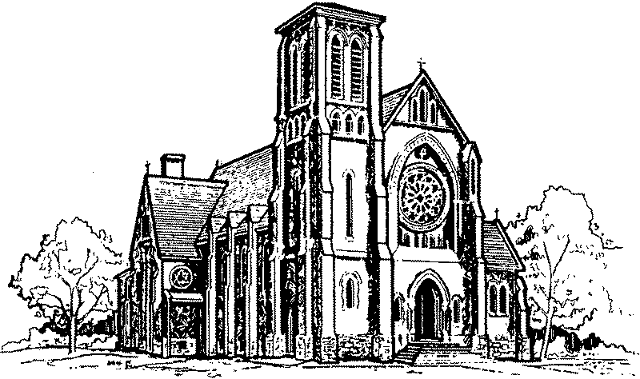
745 DUKE ST.

PASTORAL TEAM
Rev. Peter Tuyen Nguyen – Pastor
Rev. Ed Hinsperger – In Residence
Sr. Elaine Weinstein, S.S.N.D. – Pastoral Assistant
Mrs. Franki Baumtrog Mr. Dan Schmalz Mrs. Dee Donahue
WEEKDAY MASSES
Monday to Friday – 8:00 a.m.

RECONCILIATION
After the Wednesday 8:00 a.m. Mass
(until finished).
Saturday – 4:00 p.m. to 4:45 p.m.
Also, by appointment.

BAPTISMS
On the first Sunday of each month,
following the last Lord’s Day Mass.
Parental preparation is required.
SCHOOLS
St. Joseph School: 519-653-4482 St. Michael School: 519-653-3351
St. Benedict School: 519-621-4050
NEW IN THE PARISH? We welcome you!
Please fill out a registration form (found in the vestibule).
CAMBRIDGE, ONTARIO
N3H 3T7

Telephone: 519-653-6123
Fax: 519-653-4393

E-mail: stclements@rogers.com
Website: www.stclementsparish.ca

PASTORAL TEAM
Rev. Peter Tuyen Nguyen – Pastor
Rev. Ed Hinsperger – In Residence
Deacon Michael Foulger
Mrs. Franki Baumtrog Mr. Dan Schmalz Mrs. Dee Donahue
LORD’S DAY MASSES

SEPTEMBER TO JUNE
Saturday – 5:00 p.m.
Sunday – 8:30 a.m., 10:30 a.m., 12 noon
JULY & AUGUST
Saturday – 5:00 p.m.
Sunday – 9:00 a.m. and 11:00 a.m.

WEDDINGS
Wedding dates are booked with the Pastor.
Give us at least 6 months’ advance notice.

SCHOOLS
St. Joseph School: 519-653-4482 St. Michael School: 519-653-3351
St. Benedict School: 519-621-4050

NEW IN THE PARISH? We welcome you!
Please fill out a registration form (found in the vestibule).

