Dear Friends and Parishioners

of St. Clement Parish:

“Joy to the world! The Saviour is born!”

Even though this was first heralded 2017 years ago to a very broken world, its proclamation is necessary today because we remain a broken world in many ways. The difference today is that we are the ones given the responsibility to bring this Message of Joy to every part of the world.

In the days of Jesus, the people could listen to His words and see His acts of compassion and love. Imagine their great joy as Jesus spoke about His and our Father’s desire to bring us back Home; to be able to experience the joy of Eve and Adam in their time with God and one another in the Garden of Paradise! This has been God’s dream for us from the very beginning of our existence:

That we would have this joy,
“the Joy and Peace that surpasses all understanding”
in our lives today.

The Gift of Joy given to all people that first Christmas Day can never be withdrawn by God; but it is possible for each of us to lose awareness of it just as Eve and Adam did. They, Eve and Adam, were enticed to think God wasn’t giving everything which could be given to them – and that something else, they thought, would give them greater happiness. From that time on, that has been our stumbling block: That we have equated happiness with joy.
What is the difference
between happiness and joy?

Happiness is fleeting. We experience moments of happiness when we celebrate special occasions such as birthdays, weddings and accomplishments. We experience unhappiness at broken promises and in times of personal failure, deep unhappiness in times of grief such as the illness or death of a loved one.

Joy – spiritual joy – is not based on circumstances but on knowing we are one with God and that nothing and no one can break this relationship.

Let us open our hearts this Advent
that this awareness of God’s love
may be rekindled and renewed.

May that awareness bring you
the Peace that surpasses
all understanding
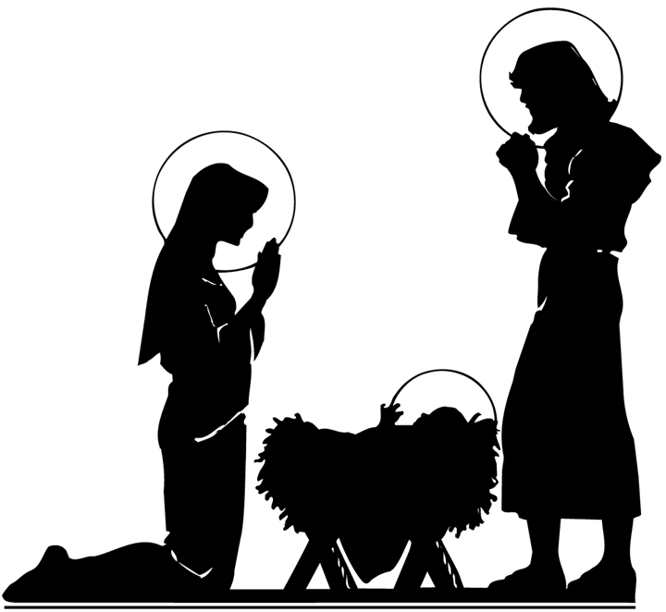
(Philippians 4:7).

May that incomprehensible
Joy and Peace be yours
in every circumstance.

We wish you a holy Advent
and a blessed, joyous Christmas!

St. Clement Parish
745 Duke Street
Cambridge (Preston), Ontario
N3H 3T7
Tel. (519) 653-6123

Advent
& Christmas
2017

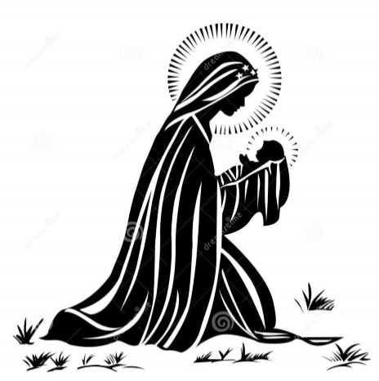

May the blessings of the
Christ Child
and His loving mother
be with you at Christmas
and always.

Solemnity of Christmas

(Holy Day of Obligation)

Christmas Vigil Masses
Sunday, December 24, 2017
- 5:00 p.m. Mass with the Children’s Christmas Pageant
- 9:00 p.m. Mass

Solemn Midnight Mass
Sunday, December 24, 2017
Christmas Carols begin at 11:30 p.m.
Solemn Midnight Mass: 12:00 a.m.

Masses during Christmas Day
Monday, December 25, 2017
8:30 a.m., 10:30 a.m. & 12:00 noon

+ + + + +

Solemnity of

Mary, Mother of God

(Holy Day of Obligation)

New Year’s Eve
Sunday, December 31, 2017
5:00 p.m.

New Year’s Day
Monday, January 1, 2018
8:30 a.m., 10:30 a.m. & 12:00 noon

T
he Sacrament of Reconciliation is a graced opportunity to celebrate the forgiveness of the Lord in our lives. This Sacrament is celebrated weekly on Wednesdays and Saturdays. Confessions are heard:

Following the Wednesday 8:00 a.m. Mass (continuing until finished).

From 4:00 to 4:45 p.m. on Saturday afternoons.

Advent Evening of Reconciliation

Tuesday, December 19, 2017
7:00 p.m.
at St. Clement Parish

E
veryone is invited and encouraged to take part in our Evening of Reconciliation on Tuesday, December 19th, at 7:00 p.m. Guest confessors will be available. This evening is a time for personal prayer and an opportunity for individual Confessions offered, that we may prepare ourselves to celebrate Christ’s birth at Christmas. Come and spend some time with our Lord.

Additional Advent

Confession Times

Friday, December 22, 2017
11:00 a.m. to 12:00 noon

Saturday, December 23, 2017
11:00 a.m. to 12:00 noon

