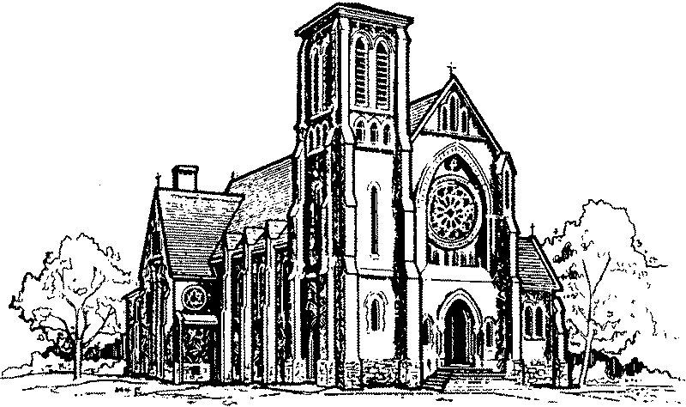

St. Clement Parish
745 Duke Street,
Cambridge, Ontario, N3H 3T7

Tel.: 519-653-6123
Web site: www.stclementsparish.ca
E-mail: stclements@rogers.com

Pastoral Team
Rev. Peter Tuyen Nguyen – Pastor
Rev. Ed Hinsperger – In Residence
Mrs. Franki Baumtrog Mrs. Dee Donahue

Finance Council
Mr. Drew Black 519-267-4007
Mr. Brian Hummel (Chair) 519-650-3752
Mrs. Anne Kinzie 519-653-9348
Mr. Pat Melady 519-242-8185

A Message from Father Peter

Dear Parishioners and Friends
of St. Clement Parish,

On this, the Feast of Divine Mercy, we present to you the 2019-2020 Spiritual and Financial Report. Before the Coronavirus pandemic, it had become a practice to present our Annual Report at the beginning of Lent. Last year, due to the province-wide State of Emergency, everything changed. The parish was closed, and Lent 2020 was like no other.

This is a bittersweet time, with yet another State of Emergency … Though at least this time, we are not fully shut down. Easter Masses were offered, and we rejoiced in our greatest blessing: Christ, our Light, is risen! We celebrate God’s unfathomable love and embrace the Good News: Death is conquered, and the hope God offers is everlasting. He is triumphant, He will prevail, and in His time, we will have the normalcy we pray for.

Until then, we look for and thank God for His blessings. Among them, is the blessing of St. Clement parish family: Ever caring, ever faithful. We continue to support each other in prayer and, despite the pandemic, by our offerings. The Lord gives to us, and in thanks we give back a portion of what He has given. It is truly remarkable. I am deeply grateful for your kindness and generosity. I thank God for every one of you!

On behalf of myself and our Pastoral and Finance Councils,
may God bless you for your goodness.

May He keep you and your loved ones safe,
giving you every consolation
and meeting every need.

Yours in Christ,

Father Peter

April 11, 2021

Spiritual Review
2019 and 2020

Number of families in the parish: ± 2,875
Number of persons in the parish: ± 6,850

2020 2019
Baptisms 76 128
Adult conversions 1 7

First Communions 41 49
Shut-ins receiving Communion 0 50
Confirmations 30 55
Marriages 5 29
Funerals 50 53

Students in Catholic elementary school Unknown ± 400
Students in Catholic secondary school Unknown ± 180

Financial Review
2019 and 2020

Balance Sheet
2020 2019
Assets $ $
Cash on Hand and in Banks 188,768.39 117,023.62
Funds on Deposit at the Chancery 240,198.31 233,132.43
Other Assets – HST Receivable, Prepaid Expenses 5,060.51 5,983.16

$434,027.21 $356,139.21

Liabilities & Equity $ $
Accounts Payable 10,656.26 10,958.02
Cathedraticum Payable / (Prepaid) (4,181.96) 15,449.69
Equity 427,552.91 329,731.50

$434,027.21 $356,139.21

Profit & Loss Statement
2020 2019
Revenue $ $
Offertory, incl. Easter & Christmas, Gifts in Kind 400,748.53 494,514.95
Maintenance & Renovation Fund 43,658.25 51,578.75
Weddings & Funerals 2,600.00 8,715.00
Bequests 6,000.00 0.00
Religious Articles 2,233.91 7,222.96
Interest Income 7,455.38 8,033.22
Rebates 24,128.94 43,591.17
Miscellaneous, incl. Catholic Missions in Canada Collection 3,075.35 7,155.74
Diocesan Collections 17,508.68 25,970.92

TOTAL REVENUE $507,409.04 $646,782.71

Expenditures $ $
Church – Insurance, Upkeep, Utilities, etc. 47,205.23 55,145.39
Rectory/Household – Insurance, Taxes, Upkeep Utilities, etc. 30,687.23 29,639.43
Salaries & Travel – Clergy, Religious & Laity 154,230.95 233,583.02
Payroll Costs – Clergy, Religious & Laity 29,114.28 32,336.69
Altar, Sacristy, Missals 7,272.02 12,821.94
Office & Administration Expenses 14,493.95 19,496.75
Parish & Fellowship Activities 2,409.91 3,574.47
Retreats, Seminars & Education 1,694.89 5,188.38
Charitable Works, incl. Catholic Missions in Canada Collection 16,867.01 23,985.72
Bank & Interest Charges 1,903.24 152.48
Cathedraticum Expense 43,834.96 64,022.54
HST – Non-refundable Portion 4,958.75 9,124.37
Major Improvements – $38,190.41 in 2020
and $129,571.00 in 2019, as follows:
- Church – Organ 0.00 26,500.00
- Church – Stained Glass Windows 16,604.00 17,368.00
- Church – Bell Ringer System 15,578.04 0.00
- Church – Other 2,354.41 8,986.26
- Rectory – Incl. Water Damage Repairs, Asbestos Abatement 0.00 56,708.61
- Furniture – Incl. Replacement of Water-Damaged Items 3,653.96 20,008.13
Diocesan Collections 17,508.68 25,970.92

TOTAL EXPENDITURES $410,371.51 $644,613.10

Net Income / (Loss) $ 97,037.53 $ 2,169.61

